Triggering Climate Investments in India

Background

At COP26 climate change conference in November 2021, Prime Minister Narendra Modi committed India to achieve ‘net zero’ emissions by 2070. The commitment meant that India as a nation will not be doing any carbon emissions and the overall net contribution by India will be zero.
As we battle climate change, while surviving Delhi heat wave at 49C with 400 AQI, the debate is no longer a philosophical one but a hard reality i.e., this year, 80% of mangoes crop got destroyed due to intense heat wave.
So what is the way forward? Will the next 48 years give us enough time to reduce our carbon emissions and become net-zero? Can this goal be achieved without compromising our development goals which aim for giving a comfortable life for all its citizens?
India consumes 1/3 of per capita energy as compared to global standards. Plastic usage is one among the lowest. India has just 4% air conditioning penetration. As India moves up on the development ladder and aims to be a 10 trillion economy in the next 10 years, there can be a tremendous demand for housing, energy, food and transportation. Same is true for all emerging economies in the world. The developed world’s per capita GHG emissions like US (16 ton per capita), Australia (16 ton per capita), Canada (16 tpc), Germany (9 tpc), UK (6tpc)) are far higher compared to India (under 2 tons per capita), and other emerging economies.
Now, imagine India, a country of 1.5 billion people in the next 10 years, consuming the same level of energy, plastics, oil, building material, and cars on a per capita basis as that of Norway or US or any other developed economy! Even a 50% per capita increase in consumption compared to the western standards will push things beyond the point of no return as far as climate change is concerned.
Key Challenge related to Climate Finance
However the discussion related to green transition has moved towards finance or rather the lack of it given extremely high numbers. As per studies done by CPI and Shakti Foundation, India requires approximately US$2.5 trillion by 2030 to meet its nationally determined contributions (NDCs) and US$10.1 trillion to achieve net-zero emissions by 2070. These figures of US$2.5 trillion by 2030 or $US$10.1 trillion in the back drop of Indian economy size / Govt of India budget, not only look audacious but seemingly impossible and that is the biggest failure of the discussion related to climate finance.
In fact all discussion related to Climate tech is getting trivialized on account of such large number as despite all the effort and good intentions, as no economy will be able to commit 2.5 times of its annual budget towards “Climate financing alone” (assuming Indian Govt budget to double by 2030 from existing US$550 bn)
Hence, the hard reality is that we cannot get energy, food or transportation using the same framework that the western world has used or by using existing technologies that are in action so far.
Hence, existing and the traditional models of power generation, distribution, air conditioning, housing, and building infrastructure is not going to work and will rather create havoc.
Capital & Innovation
This hard constraint also creates a huge opportunity for capital and innovation. China built its massive infrastructure like the west or rather much better than the west but at a much lower cost (30% to 40% cheaper than the west). Likewise, what is needed in these sectors ( energy, waste, mobility etc) is not a pure investment solution but technology solutions that can help India and the rest of the emerging world to have the same standard of living without consuming the same level of resources and that is the biggest opportunity.
The fact of the matter is that the pace of innovation in core sectors, be it power generation, transportation, agriculture or cement production (the biggest carbon emitter), has been far slower than what has been seen in the space or tech sector and hence the challenge of climate change is more of an engineering challenge as we need to generate power or transport people or build houses with technologies which are far greener and emit far less carbon. To summarise, climate change is an engineering error as emissions are nothing but the error or lack of efficiency in the system.
Hence, no level of policy framework or consumer awareness or zero-carbon commitment will solve the issue of net-zero if we continue to use existing technologies to meet our needs be it air conditioning, power generation, transportation or food production.
Climate Innovation Ecosystem
We have seen the way tech has moved the needle in the area of computing (billion transistors on a chip), autonomous vehicles and broadband through satellite, reusable space rockets. And we are already seeing the emergence of technologies in climate change which are moving the needle in a big way. The combination hydrogen and nuclear is expected to wean us away from coal and gas-powered power plants and expect to disrupt not only our energy production but also industrial processes, cooling, and food production.
So, the path to net-zero or rather the only path to net-zero will be by creating an climate innovation ecosystem along with supporting policy framework
This climate innovation framework is needed to create an enabling environment for start-ups trying to create solutions to solve climate change by channelising finance, mentorship, corporate connects.
So the first critical path to solve climate change is to focus on innovation rather than talking about huge climate finance numbers. This bring us to the next big challenge which is related to nature of finance. Of all the discussion done related to Climate financing , Grants and green bonds remain the key theme of all financing need and that is the second biggest challenge being faced by innovator / disruptors.
Grants, Bonds and Risk capital
There are a few basic challenges with grants and climate bonds. Since grants are non-repatriable capital, they create a limit on available capital, and by nature remain of small size – grants above $10 million are almost unheard of. Compare this with $10 million rounds which happen in the start-up world! Thus, despite best intentions, grants cannot ensure supply of a large amount of capital and as a result by design, keep large problems capital-deficient. Further, there are not enough incentives for teams to build faster, better and cheaper solutions. Therefore, these problems not only remain capital deficient, but also entrepreneur deficient, as entrepreneurs are not drawn to these sectors due to the paucity of funds and lack of alignment of interest.
On the other hand, climate bonds have no such challenge. A huge amount of capital is raised through green bonds and there are many examples of super-sized raises in the past few years, thus helping fund large projects. However, the challenge with bonds is that they are debt instruments. They are risk-averse, dependent on supporting equity, and the strength of the balance sheet. This risk-averse capital can drive away innovation as in a lot of cases; the best outcomes are driven by risk capital and not by debt. Imagine starting Google/Uber/Intel/Paytm by raising debt, where interest needs to be paid quarterly!
The point is that while we do need grants/climate bonds to form the basic layer of capital in order build initial infrastructure as well as support core research, the real need of the hour is risk capital which can fund innovative ideas and help entrepreneurs take bold moon shots in solving large problems.
But the question is why do we need risk capital in the first place and can a capitalistic approach really solve these issues?
Need of Risk capital for Climate Tech

Risk capital or venture capital, by its very nature, is geared towards high business failures. Almost 40-60% of the investments by funds are written off and the grand success rate of any fund is not more than 30%. However, the critical point is not the success ratio but rather the failure rate. This business model of the VC world with its high failure rate makes the whole chain of investors, from angels to large funds, mentally aware of the possibility of failure. This, in turn, results in funding of a large number of start-ups, focused on moon shots, as well as simpler pain points. Many a time these do succeed, resulting in paradigm shifts in the industry. Thus, the VC world has been able to create a large impact in every sector that they have dabbled in without necessarily focusing on impact. One the other hand, impact funds, despite their best efforts and focus on impact, have not been able to match up to to the success of VCs.
Therefore, it is quite evident that the path to success stories in the future lies with risk capital which can spur innovation and help us create a driverless car/billion transistors equivalent economy in environment-related sectors.

Challenges of Risk capital in Climate Tech space
World over the VC ecosystem operates on the principles of fail fast, fail cheap, roll out product faster, asset light models etc etc. Unfortunately all these dictum of classical VC investing models fall flat in the climate tech world. There is a good demonstration of the stages of climate tech start-up which rather to be seen from early traction or virality stage, need to be seen more from TRL (technology readiness level) stage or product viability model.

The infographics below (by Yair Reem, Extantia Capital), illustrates the classical fund cycle of an IP/Research based start-ups globally.

[FOAK = ‘First of its Kind!’]

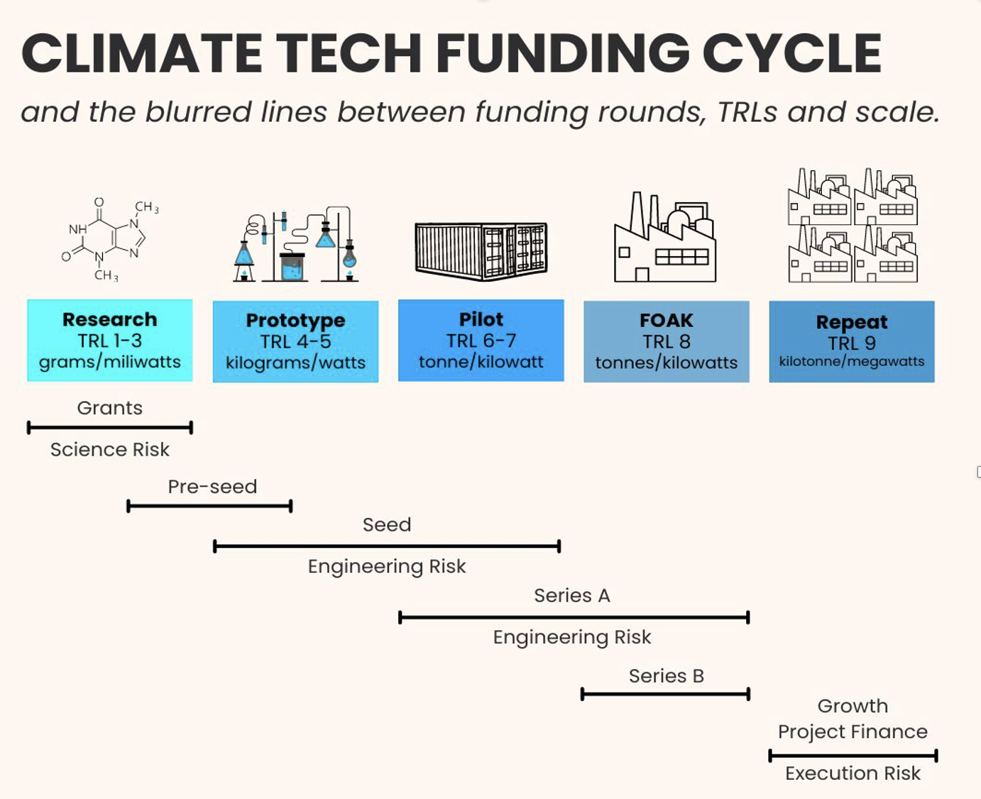

It is evident that the first level of money generally comes from grants / govt aid to tide over science risk and pre seed money / seed money kicks in during science risk and engineering risk which is quite contrary to existing VC ecosystem where majority of the seed investment happens around product -market fit and then later on marketing risk. Rarely an early-stage funding is done which has even engineering risk. Hence it is clear that present start-up accelerator/venture eco system is not conducive for climate tech start-ups and there needs to be a lot of thinking through and model building to create a conducive environment for triggering funding in climate tech start-ups.

However, it is not that climate tech start-ups just need grant at seed stage, there is equal high need to access debt at later stage as majority of these start-ups have significant assets on their books.

The chart below best illustrates the scenario of blended finance in Climate tech start-up ecosystem where grants, debt and equity capital is needed to scale the start-ups, a scenario not very common in typical consumer tech or SAAS start-ups which have been in vogue for last 15 odd years in India.

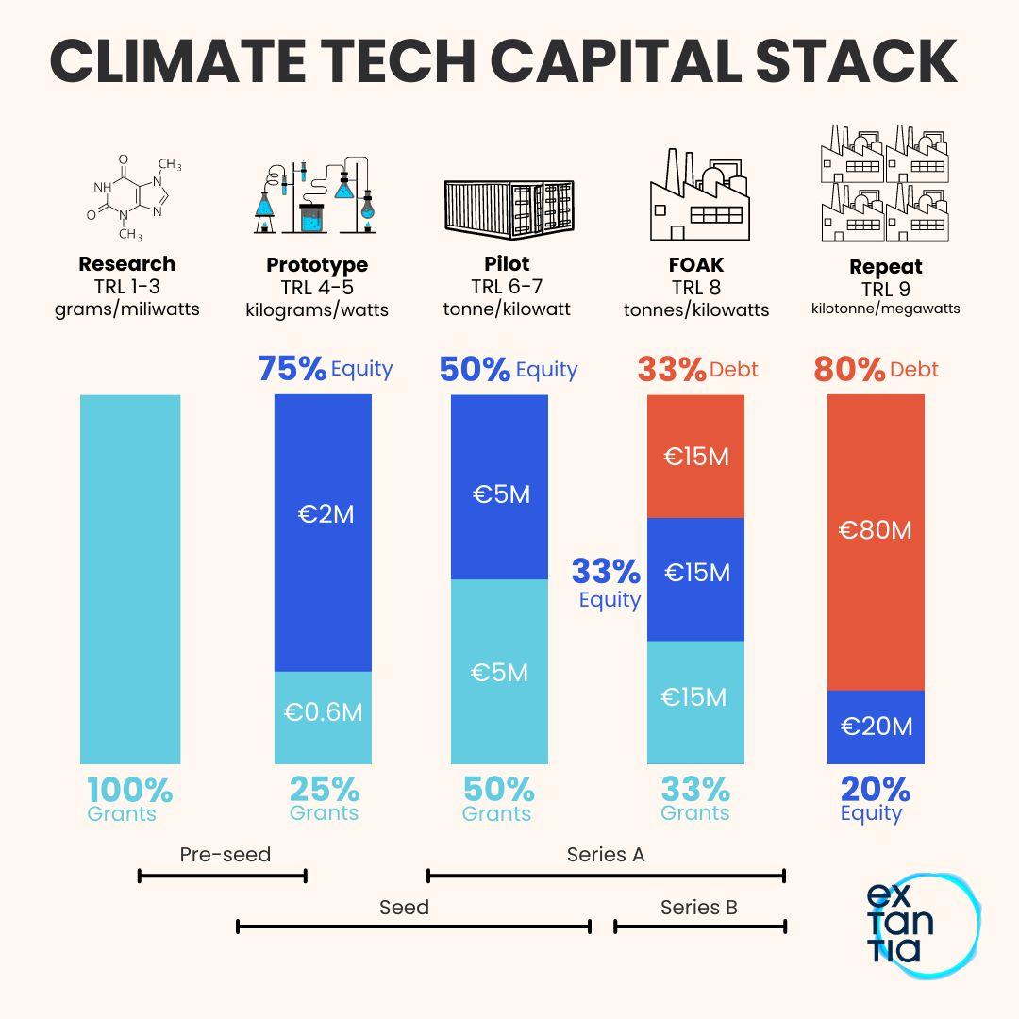
Source : Extantia Capital, Yair Reem

Hence it is clear that to trigger Climate tech innovation in India, a whole retraining or orientation will be needed for investors who are looking to invest in Climate tech as framework of SAAS or Consumer tech investing are not very relevant.

Of late there has been a considerable interest and initial traction for investing in climate tech start-ups in India. There are three key factors for this increase in interest in climate tech investments. Firstly, there are various initiatives by the Government of India to align with global best practices for reducing emissions and setting Net Zero targets. Secondly, we have seen through our investments the customers are demanding sustainable solutions. And lastly, there has been a push by limited partners and large investors to back climate mitigation & adaptation business models but at the same time, there is still not much clarity on the climate tech start-up business models as well as a lot of confusion towards issues like blended finance, asset lights, engineering risk etc.

Hence it is important to create an “Accelerator of Accelerators” for climate tech which can create training material, communication and frameworks around climate investing for accelerators, early-stage funds, micro-VCs as they are the first port of call for entrepreneurs.

There are several programs & challenges that are being run by corporates, donors, industry bodies and even by the Government of India. However, all these programs, including the ones run by MEF, focus on identifying startups, training them and giving rewards or grants or recognition but none of the existing programs is focusing on creating a robust climate tech investing ecosystem. This ecosystem is very critical for climate investing to take off.

IFC’s platform, powered by MEF, can fill this gap by targeting above mentioned problem and create case studies over a period of 3 years to prove how India can become a leader in climate tech investments.

Hence the one big focus of this program will not only be related to building engagement with accelerators but also build their capacity to understand the nuances of Climate investing so that they can engage and mentor start-ups in meaningful way.

Once capacity is created, the impact on output i.e. start-ups reaching out and raising funds will increase multifold. This will not only be beneficial to IFC but also help in creating good deal flow for Climate tech investors.

The other key focus of the program will be to bring donors, corporates and venture debt player together on the platform so as to create right framework for blended finance investing. Further interaction with corporates either directly or through their corp dev / CVC arm is critical as majority of climate tech solutions are going to have a demand among large corporate clients and these corporates can become first test bed to test these solutions as client or investor or final acquirer.

The other key feature of this program will be support in fund raising and building strong investor connects a feature that is missing in existing programs. The start-ups shortlisted within the framework will get access not only for early-stage investments but will also get access to late-stage funding connect with all leading investors.

The India Climate Accelerator Platform (ICAP) project will have following objectives:

- Identify specific sectors / sub sector where innovative technologies can be deployed for de-bottlenecking their climate / development challenges

- Tap into the climate-tech start-up opportunities developed through budding entrepreneurs, corporates, universities, think tanks etc. through IFC – India Climate Accelerator Platform (ICAP).

- Help organize deal flow and pipeline for PE/VC funds in the bankable climate tech project

- Screen and select climate start-ups with proven technologies and match them with potential clients/corporates

- Create multiple round tables with donors / corporates to create adequate opportunities for having early grants in the climate tech sectors as well as creating perfect legal framework for blended finance

- Policy dialogue on steps needed to enable for R&D grants for private sector start-ups in order to bring them to TRL level 7 or create a DARPA equivalent structure

- Conduct a rapid ecosystem assessment including providing a policy/ regulatory support to the government, wherever necessary

- Create awareness of existing initiatives from the Government

- Support adoption and uptake of the technologies through commercial partnerships, providing advisory through industry experts, think tanks and angel investors in the VC space.

Program Design
The program will consist of three modules that will work simultaneously to achieve the program's objectives. “Module 1: Investment Acceleration” will address objectives 1 to 4, while Module 2 will conduct roundtables with stakeholders to establish legal framework for blended finance as well as identify key policy blocs which can trigger grants for Climate tech R&D start-ups while “Module 3: Building Enabling Ecosystem” will achieve objectives 7-9.

.
Module 1: Investment Acceleration (addresses Objectives 1 to 4)

This module will focus on facilitating access to funding for climate-tech startups. It is important to note here that probably two different tracks will have to be created depending on the stage of startup:

- For growth-stage startups raising Series B+ (that could be considered by IFC)
- Seed-stage startups that are early-revenue

The main activities in this module will include identifying technologies, sectors, and sub-sectors in India with high climate impact potential, sourcing projects seeking funding, evaluating these projects, creating a pipeline for investors, and facilitating connections between the projects and suitable investors.

IFC-ICIP will invite applications from climate projects across major sectors, including Low-Carbon Electricity, Low-Carbon Transport, Industrial Decarbonization, Sustainable Cities, Food, Sustainable Agriculture and Land Use, Climate Resilience, and Adaptation.
These target sectors will be defined and documented to prioritize sectors and sub-sectors based on market demand assessment during the pre-implementation stage.
We will also need to deliberate whether to include sectors like water treatment or industrial air purification, which are not directly linked to decarbonization but very relevant for solving large problems in India.

We will define the eligibility/qualification criteria for IFC-ICIP and create an evaluation framework to screen and assess start-ups. This framework for climate-tech start-ups evaluation will focus on venture investible parameters like target market potential, intellectual property defensibility & founder-market fit, and account for traction, competition and other factors. This framework will be used to assess the investability, impact, and needs of the qualified applicants.

IFC-ICIP's Investment Acceleration module will source proposals on a rolling basis and provide them with accelerated support. This support will assist them in networking and building partnerships with ecosystem players from industry, civil society, academia, and the government. To create more awareness about the program and support the growth of climate tech startups in India, IFC-ICIP will host online sessions by marquee investors. These sessions will be open to all startups in India and will be held at a frequency of 1-2 sessions every month. The sessions will feature a 20-minute presentation by the investor on their investment thesis and portfolio, followed by a Q&A session with the participants.

The ultimate success of the program will be measured in terms of funding secured at the year end. The methodology detailed below will broad look at achieving the following targets:
- Create framework for evaluation
- Evaluate 200+ startups against the framework
- Create shortlist and recommend those startups to partner investors for funding

Future iterations of IFC-ICIP will build on the lessons learned during previous cycles, while assuming the continuation of the established objectives and outcomes.

Module 2 – Enabling blended finance as well channelising grants for R&D (addresses Objective 5 & 6)

The second module is focussed on one of the most important question that is enabling research grants to private sector start-ups through dialogue and policy initiates. Unlike western world, Indian universities R&D lad set up is not churning out large deal flow as of today and hence the one critical aspect is to enable donor capital to kick start R&D so as to enable start-ups reach TRL level 5 and beyond.
To enable this, we propose to host multiple round tables with all stakeholders and also release policy papers and case studies from global markets to bring out the key challenges and issues related to enable grant financing to start-ups.

Module 3 - Building Enabling Ecosystem (addresses Objective 7 to9)

The Third module of the program is dedicated to creating an enabling environment to accelerate the scale-up of climate-tech projects in India. This module aims to achieve its objectives through three key approaches.

Firstly, the program will focus on building internal capabilities and understanding of the fast-evolving climate-tech space through continuous mapping of the market, policy, and investment landscape. Secondly, leveraging IFC & MEF's experience and experts, the program will collaborate with financial actors, policymakers, civil society, and academic institutions active in the climate space to deliver models that drive start-up growth. Finally, the program will engage with other accelerators to develop a deeper understanding of sector-specific barriers to growth and involve financial institutions and policymakers in the discussions to address these barriers and build a better ecosystem.

The module will conduct a rapid ecosystem assessment, including providing policy and regulatory support to the government, where necessary. It will also create awareness of existing initiatives from the Government and support the adoption and uptake of technologies through commercial partnerships, providing advisory services through industry experts, think tanks, and angel investors in the VC space. By achieving these objectives, the program aims to create a thriving enabling environment that accelerates the growth of climate-tech projects in India.

Indicative List of Sectors

The comprehensive list of major climate-tech sectors is shown in the table below. However, the climate-tech industry in India is still developing and is not as mature as other markets such as the U.S and China. Therefore, based on market demand and growth potential, this list may undergo modifications before being implemented.

Sector | Sub Sector | Potential Focus Areas
Low-Carbon Electricity | - Electricity generation  - Transmission & distribution  - Electricity end-use | - Renewable energy generation  - Enabling and improving access to energy  - Phasing out of unabated fossil fuel generation  - Increasing flexibility of electricity provision using measures such as demand-side management and smart meters, etc.  - Grid management solutions for efficient operations  - Improving energy efficiency in end-use sectors like buildings and industry
Low-Carbon Transport | - Light-duty vehicles  - Battery storage and alternative fuels  - Mobility infrastructure  - Hard-to-abate: shipping and aviation | - Electric and alternate fuel light-duty vehicles  - Battery energy storage and management systems for application in electric vehicles  - Alternative fuels (such as green hydrogen / ammonia / sustainable aviation fuel), for application in road transport, shipping, and aviation.
Industrial Decarbonization | - Iron & Steel  - Cement  - Aluminium  - Chemicals and fertilizers  - Paper and pulp | - Energy efficiency in industrial operations  - Use of alternative fuels and feedstock (such as green hydrogen, waste, biomass, etc.)  - Innovative production technologies and alternative routes  - Resource efficiency and material circularity solutions
Sustainable Cities | - Sustainable infrastructure | - Waste management and sanitation infra.  - Water scarcity and wastewater management infra.  - Low air pollution urban infra.  - Efficient transport infra.  - Application of nature-based solutions in urban infra.
Food, Sustainable Agriculture and Land Use | - Sustainable farming  - Sustainable value chains  - Land use management  - Marine protection  - Alternative low-GHG foods | - Adoption of efficient, low-GHG farming practices (e.g. decentralized cooling to reduce perishable waste, vertical farming, etc.)  - Management and modification of natural environment through reforestation, afforestation and avoided deforestation.  - Land management practices such as soil CO2 sequestration for GHG mitigation  - Efficient operations of food supply chains to minimize food waste  - Alternative, low-GHG food production methods
Climate Resilience and Adaptation | - Adaptation and resilience to physical climate impacts  - Climate change risk assessment | Cross-cutting theme with all of the above.
Carbon Removal | - Carbon capture, utilization and storage | Carbon capture, utilization and storage

The list of sectors will be finalized at the design stage.

WORK PLAN

This section lists the major activities, outputs, tentative timelines and lead entity (between MEF and IFC, assuming the other plays a supportive role) under the two modules described above. The workplan has been divided between two stages.

Implementation stage (for the period 1st Sept 2023 to 30th June 2024)

Following activities are proposed to be executed after 30th June 2023 are indicative and a detailed / separated technical proposal & financial proposal will be submitted based on the work done till 30th June 2023 and subsequent acceptance of IFC.

- Outreach to startups
This will include following activities
  - Engagement of Digital Advertising Agency for
    - LinkedIn Ad Campaign
    - Twitter Ad Campaign
  - Engagement of a Press Release to manage monthly press articles

- Partnership engagement : Onboard partners to create climate investing eco system
  - Corporates ( CVC / Corp Dev)
  - Grant making organisations / Donors
  - Legal firms
  - Multi lateral agencies
  - Limited Partners / FoFs
- Reverse Pitching Sessions
  - Online Sessions
    - 1-2 sessions every month by marquee investors
    - 20-minute presentation (on investment thesis and portfolio) followed by Q&A session.
    - Sessions will be open to all startups in India.
  - Simple application format for each investor
    - Same application format will work for multiple investors.

- Multiple Round tables with stakeholders
  - Creation a legal framework/ term sheet to enable blended finance
  - Policy deliverable to enable grants for early stage start-ups from private sector as well as donor agencies

- Shortlisting of Applications
  - Application support for start-ups
  - First Level Screening: MEF will create a structure & grading mechanism for shortlisting of applications and submit a list to the Technical Partners (IFC subject-matter experts).
  - Advisory Board: Shortlisted applicants will be presented to the Advisory Board by MEF team for discussion and recommendation to investors.
  - Investor Introductions

- Bootcamp
  - Virtual sessions led by mentors & industry leaders all-year round.
  - Open running applications for 1-day in-person bootcamp in Bengaluru, Delhi-NCR & Mumbai (or any other city as chosen by IFC); to be held once every 2 months.
  - Recommendations & introductions made to appropriate Corporates.

